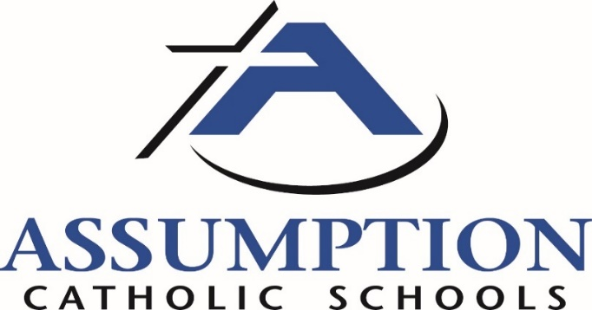

Finance Meeting September 18, 2018
Time 6:00 PM AHS Library
Agenda
- Prayer Daniel Minter
- Finance Meeting Michele Haas
  - Update on 2018-19 financials
  - Enrollment and Strategic Planning Daniel Minter
Education Commission 7 PM AHS library
- ACS 2018-19 Calendar Highlights Daniel Minter
  - Homecoming game at 11 on Saturday
  - Parish Weekends – Sept 22/23 Sacred Heart/St. Alexander
  - November 10 Auction Royale
- Approval of August Minutes ch Daniel Minter
- Reports (will bring to meeting)
  - School
  - President/Diocese
  - Athletics
  - Enrollment
  - Royal Parents
- Old Business
- New Business Daniel Minter
  - Catholic Identity Principal 1 questions on pages 9 and 10
  - 2019-20 Calendar
  - Catholic Schools Week 2019
  - WRISA instead of AdvancED
- Any other business
- Closing Prayer Daniel Minter
2018-19 Meeting Dates 3rd Tuesday of the month August 2018 – June 2019 6 PM Finance and 7 PM Commission
Oct. 16, Nov. 20, Dec. 18(Finance only), Jan. 15, Feb. 19, Mar. 19, Apr. 16, May 21 and June 18

MINUTES: Finance/Commission Meeting, August 22, 2018
6:00 p.m.
Finance Committee:
Presiding: Michele Haas
Attending:
Jeff Kuhn, Andrea Pecher, Christy Steinle, Ken Piaro, Dan Minter, Laura Cronan, Jimmy Lynch, Bob Birkhauser

- Prayer
- August Financials Reviewed
- Discussed Strategic Plan
7:00 p.m.
Commission:
Presiding: Dan Minter
Attending:
Ken Piaro, Tania Halbersma, Jimmy Lynch, Michele Haas, Russ Biebl, Craig Smits, Bob Birkhauser, Laura Cronan, Pam Fochs

Minutes: No June Minutes to approve.

Upcoming Calendar Highlights
- Drive One 4UR School Event – Sept 15th Possible donation up to $6000.
- Recycling Event – Sept 15th
- US Cellular Partnership w/ Assumption. ACS receive $50 a line for each line added or switched.
- Catechist Commissioning @ Assumption on Saturday, Sept 15th 4:00 p.m.
- Homecoming Week Sept 17-22

ACS Teachers/Staff In-Service Speaker was Mathew Kelly from Dynamic Catholic. He is the Author of the book Dream Maker.

Enrollment Update> 395 Students, 5 above budgeted. 114 voucher students this year

Building Notes
- All new ACS Staff / Teachers have been hired and are ready to go.
- OLQH hosts the new site for the Catechesis of the Good Shepherd.
- SVDP continues the school year under construction. Safety plans are ongoing.
- Dept of Justice issued ACS and additional $22,000 in security grants. The majority of these funds will be used for doorways between the school and church at SVDP for security purposes.
- St. Lawrence security cameras and security door pads have been installed and are now operational.
- Stay Smart Summer School Program was up in attendance over 50% from the summer of 2017. This program will continue for the summer of 2019.

Diocesan Updates
- Ongoing curriculum training Year 1-Religion / Year 2-Fine Arts
- Core classes are complete
- Fixed retirement program, official announcement to come from the Diocese at a later date.

Old Business
- Question was raised to again look at ACS taking over the school maintenance for the SL, SVDP and OLQH school buildings. Mr. Minter advised we will continue this discussion with the parishes.

New Business
- Raised Royal > we will continue to build on this brand. You will see it used more often this school year.
- We need to update our Strategic Plan. This is something we will begin to work on this year.
- Catholic Identity. The plan is to have commission members read one principal each month. As a group we will answer and discuss the questions.
- ACS is now using RenWeb Parent Alert for emergency communication. Parents will receive a text and email in cases of emergency. Could possible extend to non-emergent announcements in the future.
- President Minter will visit all deanery parishes on a rotation basis. After mass on Saturday he will have cookies and lemonade, and Sunday’s coffee and donuts. This is being done as a way to reach out to all deanery parishioners, introducing himself and letting them know their support is valued.
- ACS is changing who we go through for accreditation. We will be transitioning from Advanced Ed to WRISA (WI Religious Independent School Association)
  - WRISA is recognized by DPI for Choice Schools
  - Savings of $4000 a year
  - Same site visit schedule
  - For one year we will be dual accredited through Advanced Ed and WRISA to maintain our accreditation status with the DPI.

Meeting Dates
- We will continue to meet monthly.
- Exception: No school commission meeting on December 18th.
  - We will still have the finance meeting on December 18th .

Meeting ended with a prayer
Meeting adjourned at 8:04 p.m.

