January 2022 School Reports
Our Lady Queen of Heaven K-2
January 18, 2022 Commission Report
- Clevertouch interactive boards, purchased through grants, were installed in three classrooms at the end of December. They are being used in kindergarten (Mrs. Schoff) and in both second grade classrooms (Mrs. Moody & Mrs. Morrow)
- The classroom doors and school exterior doors were rekeyed by Quality Door and Hardware on Dec. 28, 2021.
- Fr. Guanella blessed our school doors for Epiphany on Thursday, Jan. 6.
- Our Christmas Pageant was held on January 11, 2022.
- Our students have read 5 million words through the AR program. A special lunch that included piano players from AHS (Andrew Yang and Molly Thomas) at lunch and LED candles on the tables was held on Friday, Jan. 14 to celebrate this accomplishment.
- Mr. Len Strigel treated the OLQH staff to lunch on Jan. 17 in honor of his late wife, Sarah.
- An air quality test was conducted in the basement. We are awaiting results. In the meantime, we are cleaning out and organizing the basement in hopes to make it useable for gym class in inclement weather.
- Plans are underway for celebrating Catholic Schools Week (January 30-February 2). Our themed dress down days will be based off of our K-2 Superkids reading program.
- Kindergarten registration is scheduled for Wednesday, Feb. 2, 2022 at OLQH from 4-6pm.
- A visitation day for incoming kindergarten students is scheduled for Friday, May 13, 2022. There will be two sessions: 9-11:00 am and 1-3 pm.

Respectfully submitted by:
Shelley Bruley

St. Vincent DePaul School – Grades 3-5

Coming Up:

Catholic Schools Week 1/31-2/7
Plans are underway to celebrate our Catholic Schools. Schedules of activities are enroute home. Participate is as much as you can, bring your family and friends…enroll any kids you know!!

Continuing:

Reading
We all know how important reading is to the success of a student. Many opportunities are given throughout the school day to guide students through this important skill. Through our STAR assessments, Accelerated Reader program, myON, Title I, and our Read Side by Side Reading program we continue to be diligent. We also supplement our student instruction with the Literacy Lab, and a Special Needs Interventionist who use researched, best-practices to guide students in strengthening their focus skills. Continue to read with kids, no matter how old they are. Teachers and students are finding the amount of writing with our new program has increased.

Safety:
Covid Protocols: We are working safely and consistently each day to make our environment available for in-person learning.
Safety Committee: Meeting weekly to update and plan safety plans and actions.

WRISA:
Even though our visit was back in October, we continue to hone our processes for the betterment of our school. Teacher committees work together to complete our WRISA Action Plans for each of our benchmarks.

Appreciation
The students and staff are troopers as they support our mission. Our hearts go out to all families in ACS that tirelessly wake up each morning to do God’s work for the children. Thank you to all who are supporting our efforts in the school both academically and spiritually.

Respectfully submitted,

Pam Fochs

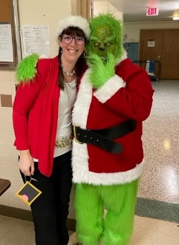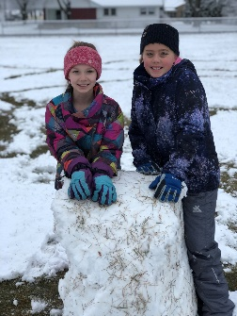

ASSUMPTION MIDDLE SCHOOL/High School (6-12)
Dec. 22 Assumption High School Golden Mass @ 1:00
Jan. 6-15 Casa Hogar Trip
March for Life
Finals/Hex 4 Began Jan 13th
Preparing for Catholic Schools Week
Technology Survey

On Dec. 22nd Assumption held our annual Golden Mass. It was a beautiful mass that included many families and alumni. I am very thankful for all of the helping hands that helped prepare for this special mass.

The Casa Hogar trip (Jan. 6-15) led by Anne Zacher and Pacelli Catholic Schools took a great group of students to serve at the orphanage which is a mission of the Diocese of LaCrosse. They worked in various capacities serving the children through manual labor and relational ministry.

A group of 30 Assumption Catholic School students are leading a trip to Washington D.C. to the March for Life (Jan 19-23). Assumption High School has invited students from St. Bronislava Parish, St. Mary’s Catholic Church (Tomah, WI), UW LaCrosse, Viterbo University, and St. James (New Lisbon, WI) to attend the march.

A technology survey was sent out to parents and faculty. There has been a good response to the survey and results are continuing to come in. Currently there are 73 parent and 28 staff responses. Once I gather all of the results I will share the results with Commission and our Assumption community.

Upcoming Dates:
Jan. 19-23 March for Life
Jan. 29 Diocese of LaCrosse Brains Competition (Date will most likely be moved)
Jan. 30-Feb. 5 Catholic Schools Week
Feb. 2 All ACS Mass @ SS Peter Paul
Feb. AHS Course Registration 2022/2023

