October 20, 2022

Dear Educator,

AgCountry Farm Credit Services is awarding several $1,000 college scholarships. The scholarships will be awarded to high school seniors who plan to enroll in college in the fall of 2023.

The recipient may be from an actively farming or ranching family or planning to pursue an agricultural career. This means that seniors from a farming or ranching family are eligible, regardless of their career intentions. Also, seniors intending to pursue ag careers are eligible, regardless of whether they have a farming background. In either case, scholarships are not awarded until the students show proof of enrollment in college.

Application deadline is March 1, 2023. Applicants must be residents of the following counties:

Minnesota Counties: Becker, Beltrami, Big Stone, Chippewa, Clay, Clearwater, Douglas, Grant, Hubbard, Kandiyohi, Kittson, Koochiching, Lac Qui Parle, Lake of the Woods, Lincoln, Lyon, Mahnomen, Marshall, Meeker, Norman, Otter Tail, Pennington, Polk, Pope, Red Lake, Redwood, Renville, Roseau, Stevens, Swift, Todd, Traverse, Wadena, Wilkin, and Yellow Medicine.
North Dakota Counties: Barnes, Benson, Bottineau, Burke, Cass, Cavalier, Dickey, Divide, Eddy, Foster, Grand Forks, Griggs, LaMoure, McHenry, McKenzie, McLean, Mountrail, Nelson, Pembina, Pierce, Ramsey, Ransom, Renville, Richland, Rolette, Sargent, Sheridan, Steele, Stutsman, Towner, Traill, Walsh, Ward, Wells, and Williams.
Wisconsin Counties: Clark, Forest, Langlade, Lincoln, Marathon, Oneida, Portage, Price, Taylor, Vilas, Waushara, and Wood.
Please make the scholarship application available to any of your seniors who meet the criteria as stated on the application. You can find the application by visiting www.agcountry.com/scholarships.

If you have any questions, please feel free to give me a call at 800-450-8933 or 701-499-2639. Thank you for helping get this message out to your students.

Sincerely,
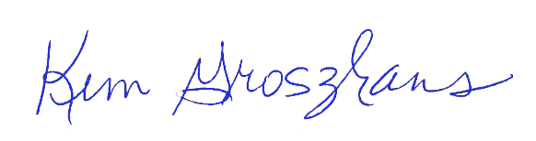
Kim Groszhans
Marketing PR Specialist - Promotions

